|  |  |
| --- | --- |
| **Project Name** | Online Survey System |
| PROJECT BATCH | 1 |
| **Platform** | Web-app |
| **Front End** | Html, CSS , Servlets, JSP |
| **Back End** | MySQL Database |

TABLE OF CONTENTS :

1. OBJECTIVE
2. ABSTRACT
3. HARDWARE REQUIREMENTS
4. SOFTWARE REQUIREMENTS
5. FUNCTIONAL SPECIFICATIONS

* USER SPECIFICATION
* MODULE SPECIFICATION

1. ER DIAGRAMS
2. UML DIAGRAMS
3. CLASS DIAGRAMS
4. DATA DICTONIARY

10.POST IMPLEMENTATION

11.FUTURE ENHANCEMENTS

OBJECTIVE :

Online Survey System Project is a web-based application developed in Java programming

language to facilitate online survey. The main aim of the project is to form a platform to

collect the viewpoints of related people about certain issue using the internet. Along with

launching survey, it is capable of giving e-mail notifications. It can be implemented in any

organizations or college for carrying out survey of any kind.

ABSTRACT :

The Online survey System is easy to use, full-featured and flexible Online Survey Information System web portal. It allows Administrators and Researcher to set different survey and survey question banks for registered members. Using different features of the researcher can set a survey category, survey name, select survey, and assign questions for survey and set the survey options.

**HARDWARE REQUIREMENT**

**Client side:**

|  |  |
| --- | --- |
| **RAM** | 2-4 GB |
| **Hard disk** | 10 GB |
| **Processor** | 2.0 GHz |

**Server Side:**

|  |  |
| --- | --- |
| **RAM** | 2-4 GB |
| **Hard disk** | 20 GB |
| **Processor** | 2.0 GHz |

------------------------------------------------------------------------------------------------------

**SOFTWARE REQUIREMENT**

**Client side:**

|  |  |
| --- | --- |
| **Web Browser Google, Mozilla Firefox etc.** |  |

**Server side:**

|  |  |
| --- | --- |
| **Web Server** | Tomcat server |
| **Database Server** | MySql |
| **Other Softwares** | Eclipse, Mysql-Workbench , Java |

------------------------------------------------------------------------------------------------------

**FUNCTIONAL SPECIFICATIONS:**

**User Specification:**

Admin : can add a survey page .

User : User can create an account and he can login with his valid credentials which was given by him while registering the account .

Survey : It helps the users to find information on the user’s interest survey .

------------------------------------------------------------------------------------------------------

**MODULE SPECIFICATION :**

**Student Education :**The user will get the information regarding the career choice’s he has in his education field.

**Agriculture: The user will get to know the types of agricultures and it’s importance**

Tourism : The user can know the exciting places around the India .

**Feedback** : The user can grade a points of 1- 10 on a scale .

**Contact us** : It display’s the admin details and works .

**Logout**: It helps the user’s to logout of their accounts .

------------------------------------------------------------------------------------------------------

**E-R DIAGRAM**

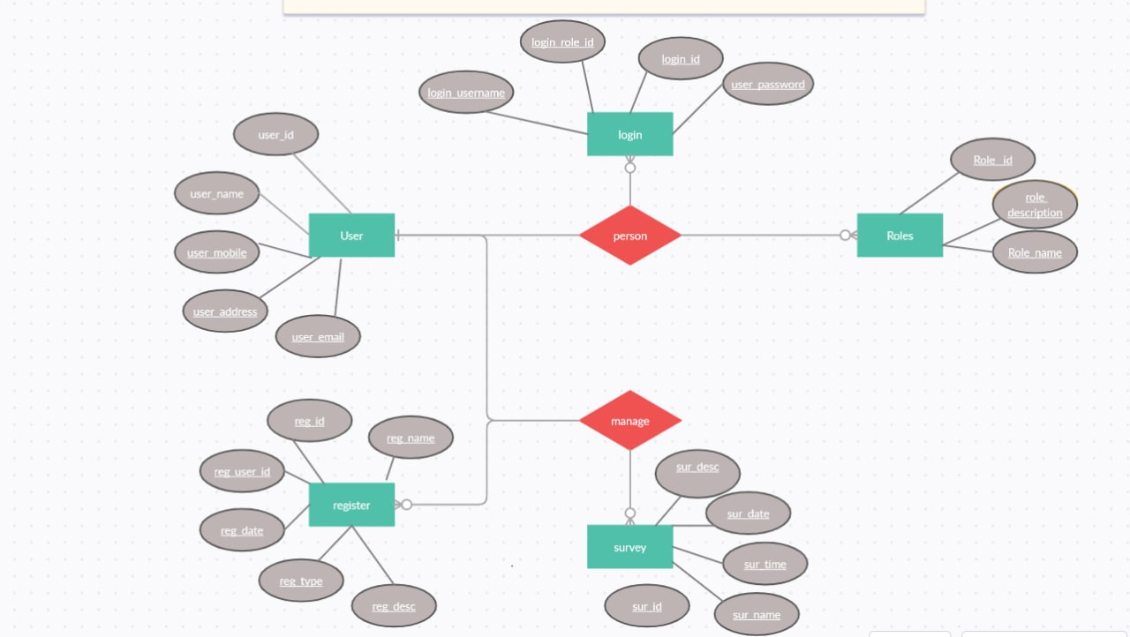

------------------------------------------------------------------------------------------------------

**UML DIAGRAMS**

* **Use Case Diagram**

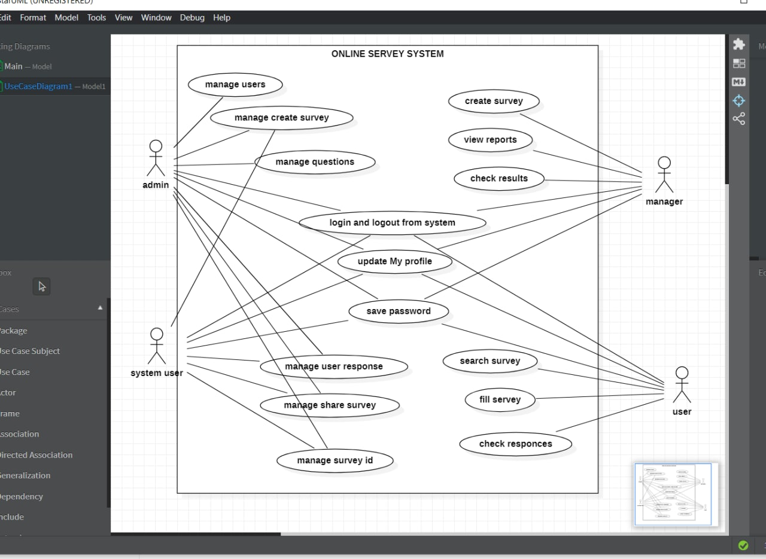

------------------------------------------------------------------------------------------------------

**Class Diagram**

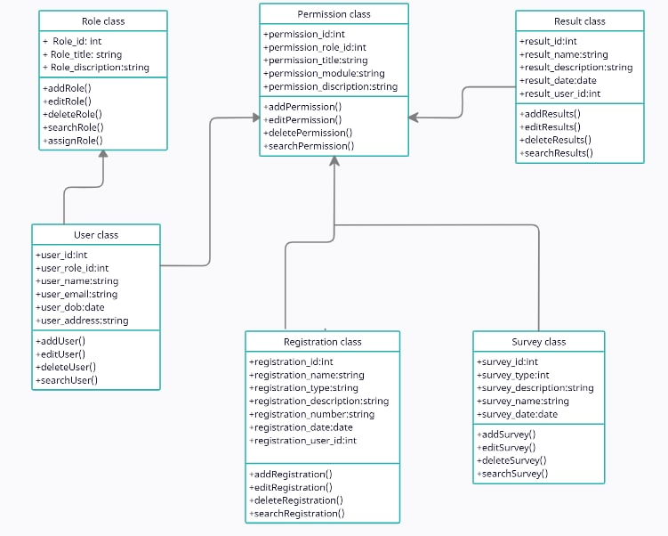

------------------------------------------------------------------------------------------------------

**DATA DICTIONARY :**

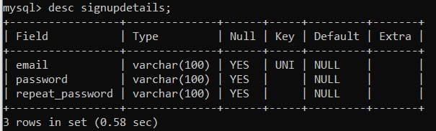

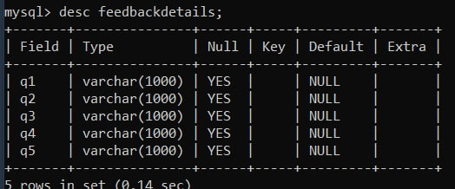

------------------------------------------------------------------------------------------------------

**POST IMPLEMENTATION**

* The website application is  self maintained.
* There is no need provide post implementation support.
* The admin can access add, edit, delete process.

**FUTURE ENHANCEMENT**

* Add new Interesting surveys

------------------------------------------------------------------------------------------------------